**Cotton, Olive (1911**–**2003)**

Olive Cotton was one of Australia’s leading twentieth-century photographers. She became a skilled observer of nature, incorporating in her work both the principles of Pictorialism and Modernism. Developing an early interest in photography after receiving Box Brownie for her 11th birthday, Cotton took pictures and experimented throughout her years of formal education. She joined the Sydney Camera Club and the Photographic Society of NSW in 1929 where she met photographers including Harold Cazneaux. Graduating with a BA in 1934 from the University of Sydney, she joined Max Dupain’s photographic studio that same year as an assistant and managed the studio from 1942–45 during his absence on war service. By the late 1930s she had developed her own style, using nature and still life in carefully composed studies of light and form. With a keen interest in the natural world, she found beauty in the landscape, particularly the smaller details of plans and flowers. She combined this with her interest in the scientific structure underlying nature, an interest sparked by her father, a geologist. She took a long time to wait for, or experiment with, the right light for a composition, enabling her to create intimate studies of the patterns, seasons, and fragility of nature.

Briefly married to Dupain, she eventually settled near Cowra, NSW with her second husband, Ross McInerney, and devoted most of her time to childrearing and the challenges of farm life, removing her from the art photography environment for nearly twenty years. In 1964 she opened her own studio in Cowra, initially photographing weddings and eventually focusing on her own art photography. In the 1980s she re-emerged into public view when feminist art scholars began to focus on her work, establishing her reputation in several exhibitions, including *Silver and Grey*, Art Gallery of New South Wales (1980), *Australian Women Photographers 1890-1950*, a touring exhibition (1981-82); and *Olive Cotton Photographs 1924-1984*, Australian Centre for Photography (1985).

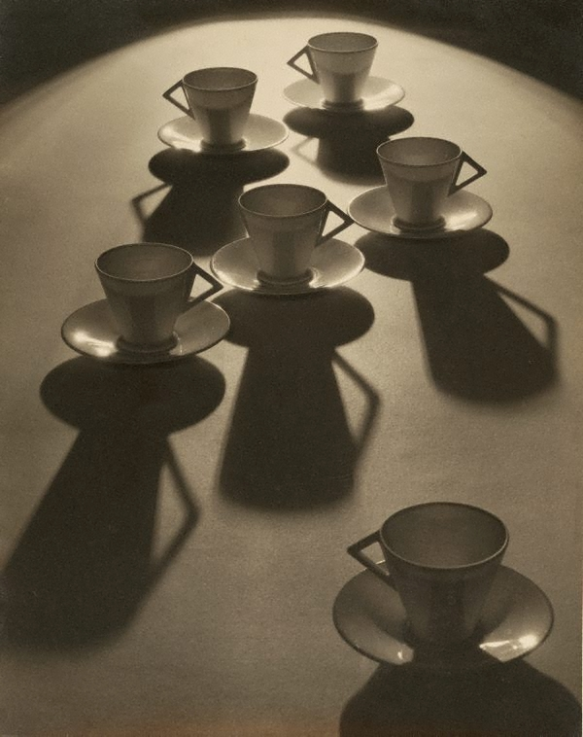

[Cotton1.jpg]

Olive Cotton, *Teacup Ballet*, c.1935, silver gelatin print, 37.3 x 29.6 cm, Collection: Art Gallery of NSW, Accession No. 218.1980, Copyright – estate of artist?

Her most well-known work is *Teacup Ballet*, c.1935, which was exhibited in the London Salon of Photography in 1935. Two years later *Shasta Daisies* and *Winter Willows* were also exhibited in the London Salon. In creating *Teacup Ballet* she had bought some inexpensive cups for the studio and said that “the angular handles reminded me of arms akimbo, and that led to the idea of making a photograph to express a dance theme.” She experimented with lighting and chose a spotlight to create long backlit shadows. Using an acute angle on the subject, the result is a composition that evokes the pattern of a lively dance on a spot-lit stage.

*Shasta Daisies* 1937, (<http://www.artgallery.nsw.gov.au/collection/works/127.2013/>) is also a reminder of her method of close observation and the formal principles of the natural world, she repositioned the flowers many times till the abstract shapes filled the lens and the flowers were suffused with light from behind, creating, as she put it, “a feeling of outdoors.”

Cotton lived to see the revival of interest in her work and was the subject of a 1991 film *Light Years* on her life and work. Also in 1991 *Teacup Ballet* was issued on a stamp to commemorate 150 years of Australian photography. Cotton is also commemorated in the acquisitive Olive Cotton Award for excellence in photographic portraiture, run biannually by the Tweed Regional Gallery.

**References and further reading:**

Ennis, Helen. (1995) *Olive Cotton: Photographer*, Canberra: National Library of Australia.

Millard, Kathryn. (1991) *Light Years*, documentary film (47 mins.), Ronin Films.